D212: Data Mining II – Task 2
IT Department, WGU
By Andrew Fagundes
Professor Kesselly Kamara
October 27th, 2025

Table of Contents
Part I: Research Question 2
A1: 2
A2: 3
Part II: Technique Justification 4
B1: 4
B2: 4
Part III: Data Preparation 5
C1: 5
C2: 5
Part IV: Data Analysis 6
D1: 6
D2: 6
D3: 7
D4: 8
D5: 8
References (No third-party code references used) 9

Part I: Research Question

A1:
Can principal component analysis reduce the dimensionality of a medical dataset without losing relevant patient information to understand the influences on hospital admissions?

A2:
This analysis aims to reduce the dimensionality of continuous variable data using PCA, enhancing future analyses’ effectiveness and efficiency. PCA reduces features while preserving most data information, simplifying models, accelerating training, and reducing overfitting. It removes redundant or highly correlated variables, making high-dimensional data easier to visualize and interpret. By focusing on informative patterns in healthcare data, we can identify patient features that correlate with hospital admissions, thereby improving patient care and enhancing cost-effectiveness.

Part II: Technique Justification

B1:
PCA reduces a dataset into uncorrelated principal components (Jaadi 2025). PCA analyzes how data points vary across all dimensions (features) and identifies the directions (principal components) in which the data varies the most. Each component captures as much variance as possible, while being independent from the others. PCA standardizes continuous variables to ensure a similar scale (Jaadi 2025). It then calculates the covariance matrix to identify correlations and determines the principal components that capture the most variance (Jaadi 2025). The dataset is projected onto these components, focusing on important variables and reducing noise. This helps to understand important patient traits that impact hospital admissions, enabling productive treatment planning by categorizing patients based on their characteristics. If certain traits predict higher rates of hospital readmissions, then hospitals can address staffing and make informed decisions to prevent these accordingly.
PCA reduces dimensionality, uncovers uncorrelated principal components, explains variance, and offers insights into patient data. The dataset with fewer dimensions simplifies visualization and analysis while preserving most original variance. Each independent principal component offers unique information about data variance. The explained variance ratio indicates the proportion of the dataset variance accounted for by each component, helping to understand the retained information. PCA simplifies the dataset, revealing significant patterns and relationships linked to patient outcomes.

B2:
One assumption of PCA is that the directions of highest variance represent the most informative or meaningful structure in the data. Sometimes, low-variance components can still be important (e.g., in classification tasks where subtle differences matter). An example would be in genetics or finance, where rare but meaningful signals might have low variance.

Part III: Data Preparation

C1:
The following continuous variables were selected for analysis: TotalCharge (continuous), Additional_charges (continuous), Doc_visits (continuous), Income (continuous), VitD_levels (continuous), Full_meals_eaten (continuous), Age (continuous), Initial_days (continuous)

C2:
The prepared dataset in CSV format is in the attached ‘D212_Task2_Data.csv’ file.

Part IV: Data Analysis

D1:
The PCA component matrix shows the weights of each variable in each principal component. Each column represents a principal component, and each row represents an original variable. There are eight columns that contain principal components and eight rows that contain original variables. Larger absolute values indicate a stronger variable’s influence on a component. For example, the variable with the largest influence on PC1 is TotalCharge since its absolute value is 0.702.
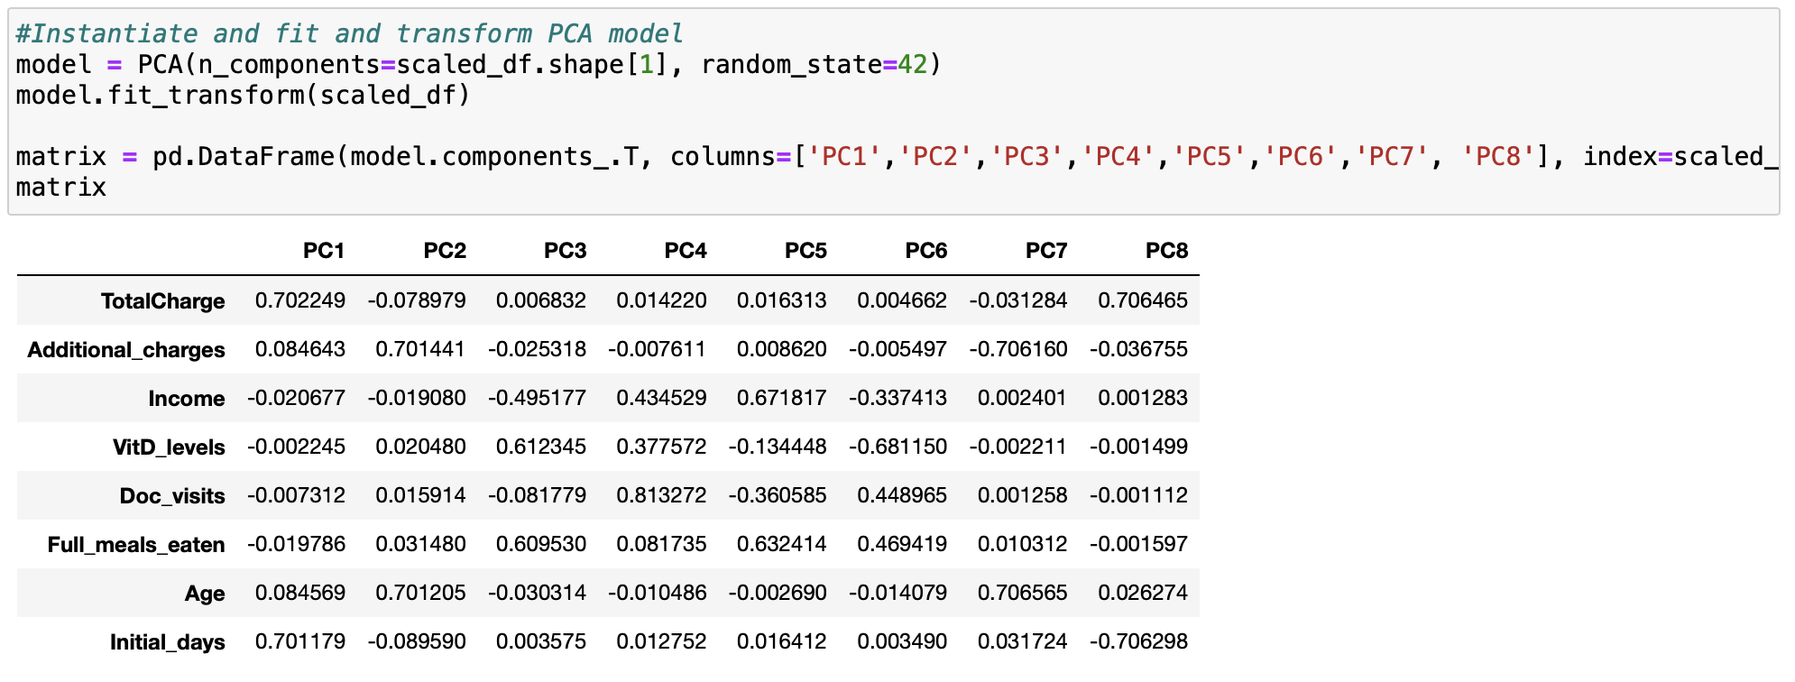

D2:
The model’s explained_variance_ attribute is used to extract eigenvalues, which are then visualized in a screen plot. The Kaiser rule states that PCs with eigenvalues greater than one are retained, while those below are dropped. From the visualization and the list of eigenvalues, the first four PCs are retained as they have eigenvalues exceeding one. 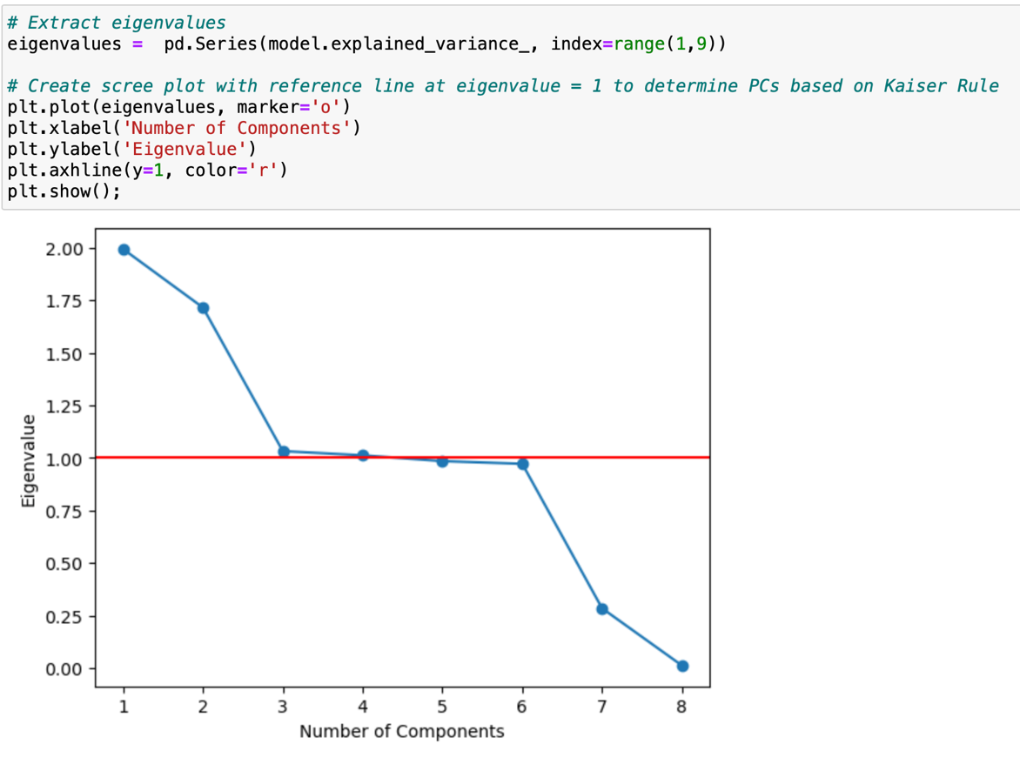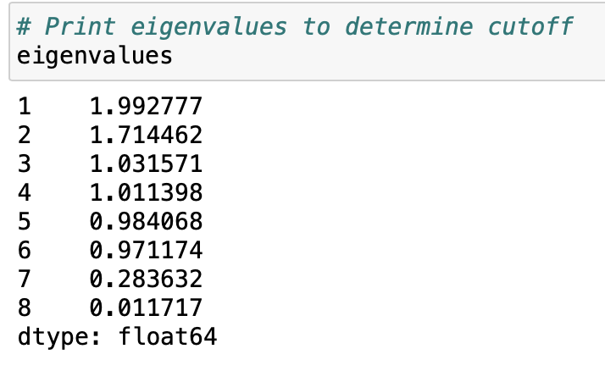

D3:
The variance captured by each of the 4 selected principal components is shown below. PC1 explains 24.91% of the variance, followed by PC2 with 21.43%. Component PC3 explains 12.89% of the variance, while Component PC4 explains 12.64%. 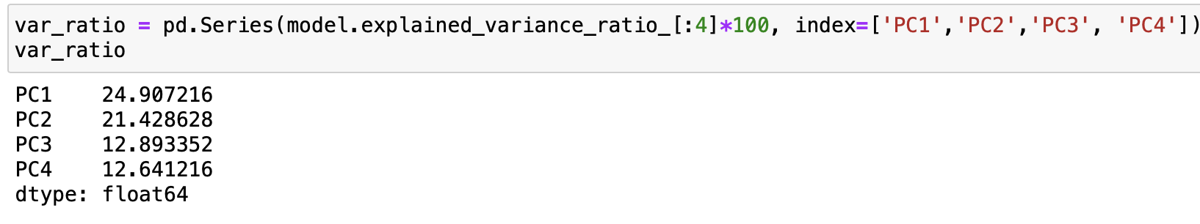

D4:
The four principal components account for 71.87% of the dataset’s variance.
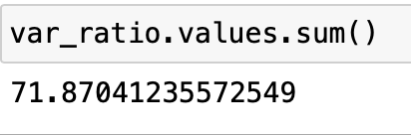

D5:
The PCA analysis reduced the dataset’s dimensionality while preserving most variance. It revealed 4 components explaining most variance: PC1 (24.91%), PC2 (21.43%), PC3 (12.89%), and PC4 (12.64%).
Retaining the first 4 components captures 71.87% of the original variance, preserving nearly all dataset information. The Kaiser criterion selected 4 components to balance dimensionality reduction with retained variance.
PCA analysis reveals that financial burden, length of stay, patient age, socioeconomic status, and additional care significantly contribute to hospital readmissions. Addressing these factors improves discharge planning, targeted interventions, and patient outcomes, lowering readmission rates.

References
Zakaria, Jaadi. Principal Component Analysis (PCA) explained. Built In. (2025, June 23). https://builtin.com/data-science/step-step-explanation-principal-component-analysis

